Use Case and Design Specification Raise Query
Project – TEKDESK

Author: Bharath R
Document Number: Use Case and Design Specification Raise Query V1.0
Document Version Number: Version V1.0 Last Modified: 3rd May 2021

Table of Contents

1. Name 2
1.1 Brief Description 2
1.2 Actor Description 2
1.3 Screen Mockup 2

2 Pre Conditions 3

3. Flow of Events 3
2.1 Basic Flow 3

4. Post Conditions 4
5. Document Change History 4

Use Case Specification- sample

Name
Raise Query

Brief Description
This use case describes the scenario after the employee successfully logs in using his/her username and password.

Actor Description
Employee who wants to Raise Query.

Screen Mockup

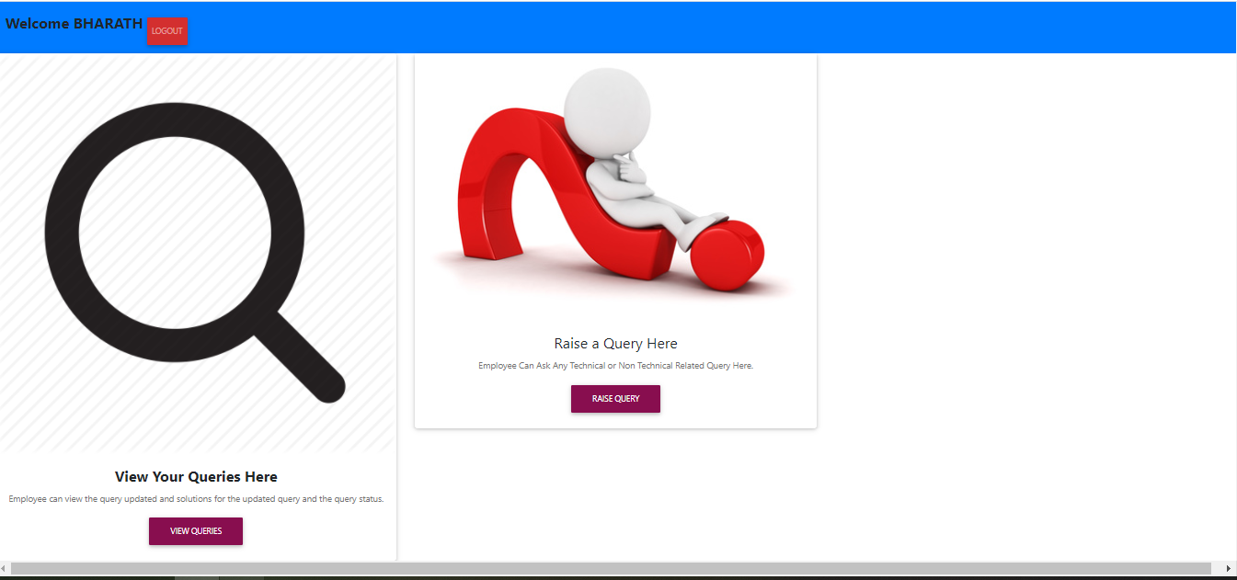

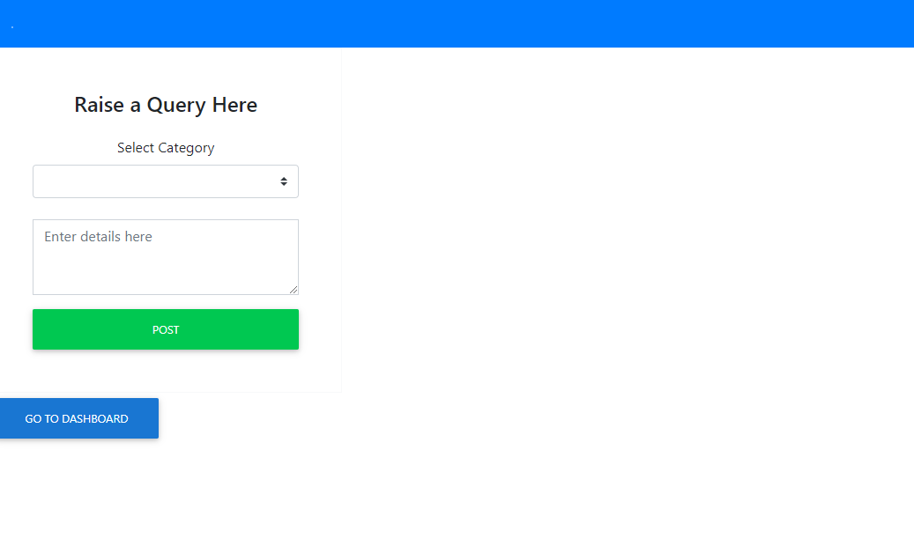

Pre-Condition
Employee has to successfully complete login process.

Flow of Events

Basic Flow

- The use case begins when the employee logs in.

- A new Welcome page will be displayed.

- When the employee clicks on Raise Query button the page navigates to the page where the employees can the Raise Query.

  - Raise Query page displays the drop-down button to choose category and text box to write what exactly is the issue.

  - Here is a list of few categories.

Sl no. | Category
1 | Software
2 | Hardware
3 | Infrastructure
4 | Finance
5 | Networking

  - After successfully Selecting Category and writing Comments click on POST button. Thus, completing the process of raising query.

  - Now click on Go to Dashboard button to return back to Welcome page.

Post Conditions
After successfully Raising Query now the employee can view his/her Query.

Document Change History

Date | Author/Editor | Description of Change(s)
03/05/2021 | Bharath R | Version 1.0

